SS8H8c Discuss the impact of the political career of Eugene Talmadge.
EUGENE TALMADGE
Eugene Talmadge was elected governor of Georgia four times (1933-1937) and (1941-1943) due to the County Unit System’s power in rural areas. This allowed Eugene Talmadge to win his elections despite not having the popular vote in the state. Many of his supporters were rural residents who favored a white supremacy culture of Jim Crow laws and disenfranchisement of African-Americans. While Talmadge was governor he opposed many of President Roosevelt’s New Deal programs b/c he did not want the Federal government interfering with Georgia politics.

Sadly, many of FDR’s New Deal programs were designed to help people living in rural areas (AAA and REA). Talmadge also was criticized for abusing his power as governor. He once fired university faculty members for trying to integrate (allow blacks to attend all-white Georgia colleges). As a result, the Southern Association of Colleges and Schools (SACS) withdrew Georgia’s accreditation in all of the all-white colleges. Talmadge’s actions angered many white voters. Talmadge lost the next election to Ellis Arnall.

SS8H8a Describe the impact of the boll weevil and drought on Georgia.

BOLL WEEVIL
The boll weevil is a beetle insect that lays its eggs in the boll (seed pod) of a cotton plant. The maturing boll weevil survives by feeding off the cotton fibers inside the boll. The impact of the boll weevil on Georgia is that it destroyed part of the cotton farmer’s crop. This led to farmers (especially sharecroppers) not being able to make a profit, which also meant that they could not pay off their loans from banks, or their debt to landlords. In addition, the decrease in cotton production also affected textile mills and other cotton industries. The boll weevil killed King Cotton, but also helped to diversify the economy by focusing on other crops like peanuts and onions.



1924-1927 DROUGHT IN GEORGIA
A drought is a period of time when a region receives less than normal rainfall over an extended period of time. In the 1920s, Georgia experienced a severe drought that devastated the economy. Unlike the boll weevil which destroyed cotton, the drought affected all agricultural crops. Many farmers lost money because their production decreased, which resulted in either less profits or losing money. Sharecroppers were unable to pay off their debts to landowners and those who were not in debt decided to quit farming and move to the urban areas of the state and work in factories. Georgians were suffering even before the Great Depression.

SS8H8b Explain economic factors that resulted in the Great Depression.

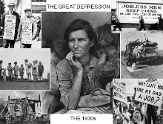
DESCRIBE THE GREAT DEPRESSION
The country experienced deflation, which is a decline in the average price level. The prices of goods and services decreased by nearly 30 percent. With lower prices, businesses such as textile mills, railroads, farmers, car manufacturers and others earned less revenue (money). With less revenue, businesses could not afford to pay people as much and/or employ as many people. The economy suffered unemployment as high as 25 percent, and wages fell. As prices decreased, business revenues decreased, wages decreased and unemployment increased. When people were earning less or were unemployed and were not earning any income, they bought fewer goods and services. As a result, businesses earned even less revenue. With wages decreasing and unemployment increasing, borrowers were not able to repay loans. Loan defaults and bankruptcies followed, which produced more bank failures and further declines in output, prices and employment. These events would lead to the stock market crash in 1929, further weakening the economy and increasing the unemployment rate.

1920s: THE ROARING TWENTIES
After World War I ended in 1918 the United States experience a decade of economic growth. The assembly line process allowed for the mass production of consumer goods such as refrigerators, radios, and telephones. Businesses grew when consumers started using CREDIT to pay for the new goods and services. In 1920, women finally had the right to vote and Americans were enjoying a period of freedoms, however, in the South, Jim Crow laws still denied African-Americans equal opportunities economically, politically, and socially.

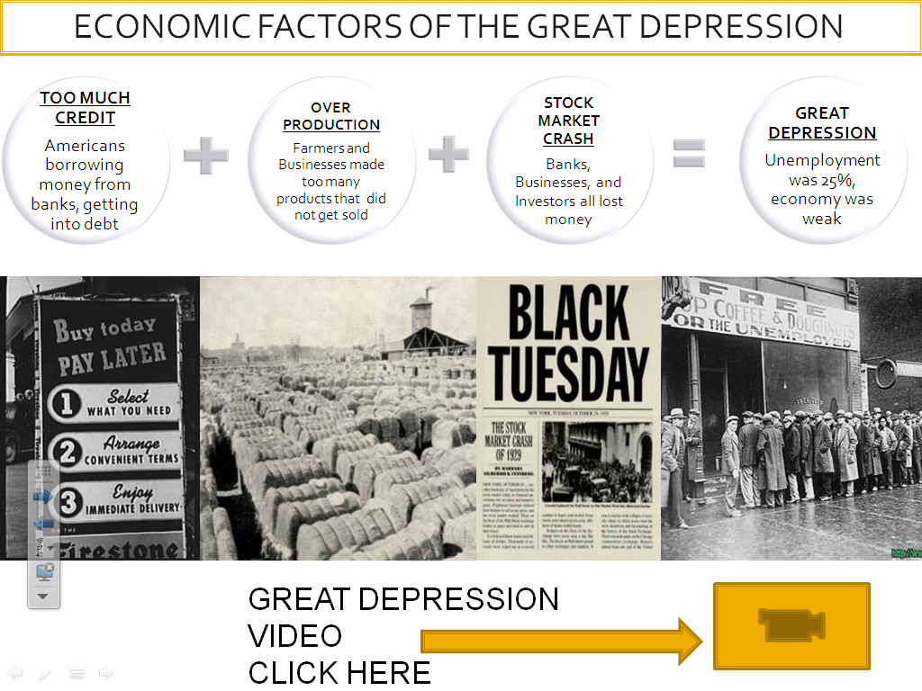

SS8H8d Discuss the effect of the New Deal in terms of the impact of the Civilian Conservation Corps, Agricultural Adjustment Act, rural electrification, and Social Security.
PRESIDENT FRANKLIN D. ROOSEVELT AND THE NEW DEAL PROGRAMS
President Roosevelt helped the U.S. economy recover from the Great Depression by creating many federal government “New Deal” programs. The purpose of the New Deal programs were to provide economic ”relief, recovery, and reform”. Each program was designed to fix or help different parts of the economy and certain groups of America’s population, especially the unemployed. When people have jobs, they spend money on goods and services, which allow businesses to grow and hire more workers, and the cycle continues. The government also benefits by collecting (revenue) money from income, property, and sales taxes.

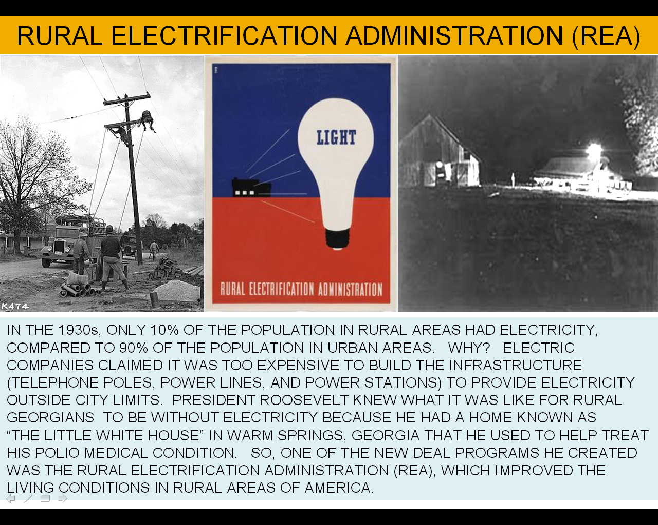
f

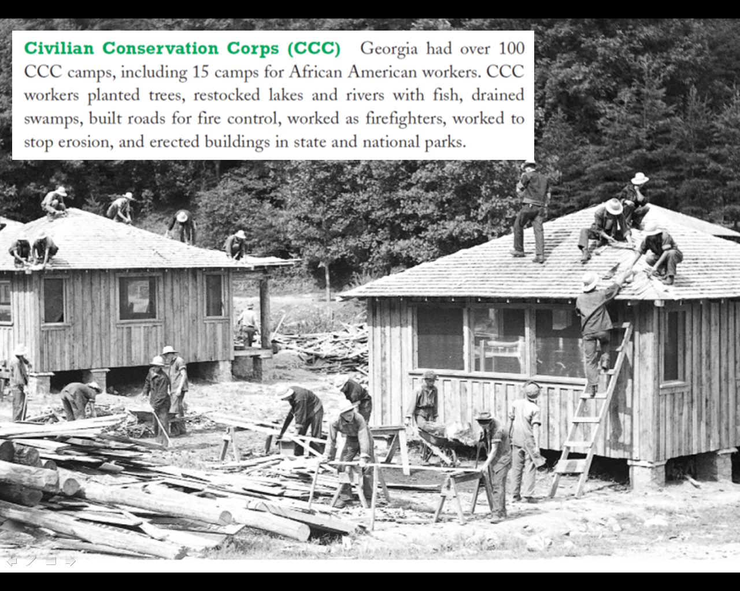

Civilian Conservation Corps (CCC)
3 million unemployed men work to create parks, roads, and other public facilities. Unemployment rates dropped and more income meant more spending to increase economic growth.
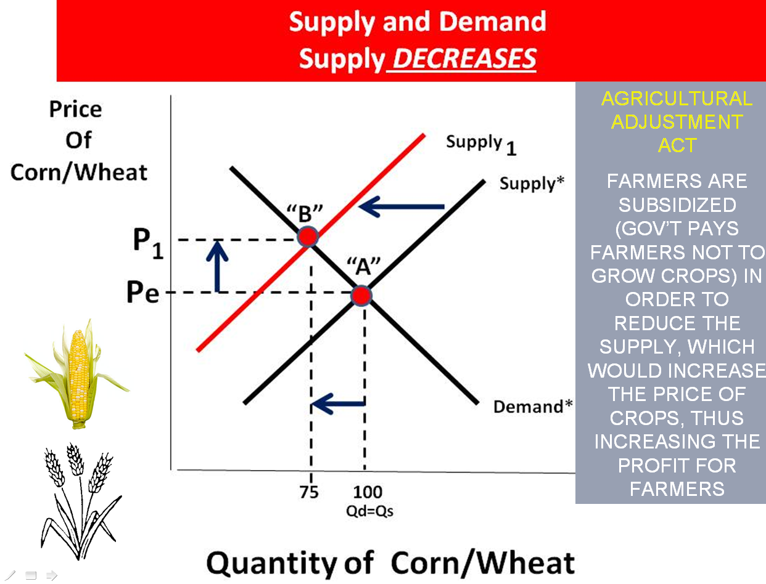
Agricultural Adjustment Act
The government subsidizes (pays) farmers NOT to grow crops or raise livestock on portions of a farmer’s land. This lowers the quantity of products, which increases the price of the goods at the market, allowing farmers to earn a greater profit and pay off their debt. Sharecroppers, however, suffered due to losing their jobs on the farm.

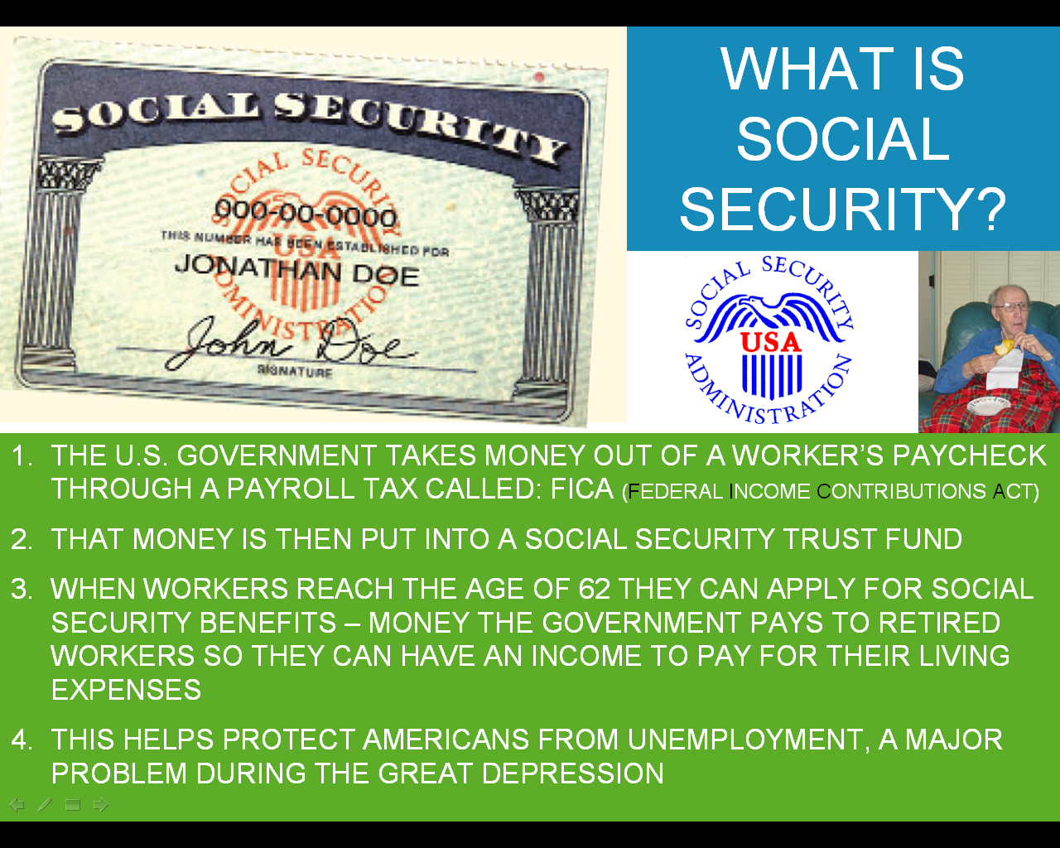
Gadoe.org - The last program that had a lasting effect on Georgia was the Social Security Act (SSA). Until 1935, those who were too old or unable to work were dependent on the charity of others. The Social Security Administration offers benefits for those over 65, those who are disabled, or those who are the survivors of a beneficiary who has died. This program is one of the longest running of the New Deal, and today most Georgians are connected to the SSA either through paying social security taxes or receiving social security benefits. This income is taxed through FICE (Federal Income Contributions Act).

