-Practice
Antebellum Period to the Civil War

SS8H6 The student will analyze the impact of the Civil War and Reconstruction on Georgia.
a. Explain the importance of key issues and events that led to the Civil War; include slavery, states’ rights, nullification, Missouri Compromise, Compromise of 1850 and the Georgia Platform, Kansas-Nebraska Act, Dred Scott case, election of 1860, the debate over secession in Georgia, and the role of Alexander Stephens.

Slavery

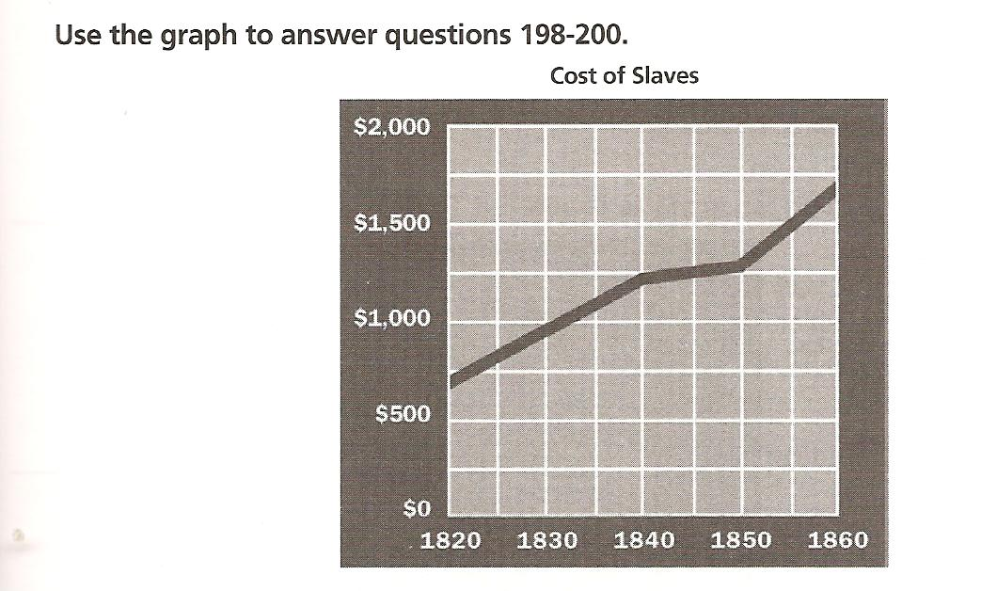

_____1) How much did a slave cost in 1840?
a. $750 b. $1,000 c. $1,250 d. $1,500

_____2) In what year did slaves cost the least?
a. 1820 b. 1830 c. 1840 d. 1850

_____3) During what ten-year period did the cost of slaves stay the same?
a. 1820 – 1830 b. 1830 – 1840 c. 1840 – 1850 d. 1850 – 1860

_____4) Why were people from Africa brought to Georgia?

a. to help fight Georgia’s enemies
b. to settle the backcountry
c. to be forced into labor
d. to help produce silk

_____5) Which statement BEST explains why there are so few accounts written by slaves about their lives during the antebellum era?

a. It was illegal for slaves to learn to read and write.
b. Only abolitionist leaders wrote books about slavery.

c. Books about slavery were not as popular as other books.
d. Slaves were not willing to write about the horrors of slavery.

_____6) What was the major type of labor used on Georgia’s plantations before the Civil War?

a. indenturered servitude
b. hourly wage labor
c. sharecropping
d. slavery

States’ Rights

_____7) Which region of the United States believed that the states should be able to govern themselves without interference from the national government?
a. Great Lakes states b. Northern states c. Pacific Coast states d. Southern states

_____8) States’ rights can BEST be defined as the belief that states
a. could not free their states.
b. could leave the Union at any time if they chose to.
c. could ignore national laws if they were harmful to the state.
d. could force the national government to turn over all national government property to the states.

_____9) Someone who believed in states’ rights would probably support which statement?
- National laws always take precedence over state laws.
- The national government has no right to tell states how to operate.
- States could only pass legislation on issues set out in the U.S. Constitution.
- Disputes between states should always be settled by the national government.

Nullification

_____10) The early 1800s belief of some people that a state could refuse to enforce a federal law was known as
a. absolution b. justification c. nullification d. ratification

_____11) In 1832, the state of South Carolina attempted to exert its state’s rights by nullifying a Congressional tariff. Who had said that this action was permitted?
a. John C. Calhoun b. Henry Clay c. Zachary Taylor d. Millard Fillmore

Missouri Compromise

_____12) The purpose of the Missouri Compromise was to

a. return slaves captured in free states to slave states.
b. allow slavery in Maine but not in Missouri.
c. maintain a balance of slave and free states.
d. let Missouri have slavery until 1850.

_____13) Which states BEST describes the failure of compromise?

a. Compromise kept a balance between slave and free states.
b. Compromise is only possible among rational people.
c. Compromise did not prevent the Civil War.
d. Compromise is usually short-lived.

_____14) Which was the result of the Compromise of 1850?
- Owning slaves was forbidden in Washington, D.C.
- Slavery was permitted in the new state of California.
- Importation of slaves from Africa was declared illegal.
- Runaway slaves had to be returned to southern owners.

_____15) Which outcome resulted from the Compromise of 1850?
- Slavery was eliminated in the District of Columbia.
- California was allowed to enter the Union as a free state.
- Texas was allowed to annex New Mexico extending slavery into that territory.
- Popular sovereignty was established, allowing states to vote on whether or not to have slavery.

_____16) The “Georgia Platform” was a statement supporting

- states’ rights.
- popular sovereignty.
c.the Compromise of 1850.
d. slavery throughout the United States

_____17) The purpose of the Constitutional Union party in Georgia was to
- preserve the Constitution.
- replace the Republican party in the South.
- get acceptance of the Compromise of 1850.
- illustrate the differences between the North and South.

_____18 The purpose of the Fugitive Slave Act to
- require slaves to have citizenship papers in order to obtain jobs.
- prevent slaves from testifying against whites in court trials.
- require slaves that had run away to go back to their owners.
- prevent slaves from having group gatherings or meetings.

Kansas-Nebraska Act

_____19) Who was responsible for the passage of the Kansas-Nebraska Act?

- Henry Clay b.Stephen A. Douglas c. Abraham Lincoln d. Daniel Webster

_____20) How did the Kansas-Nebraska Act change the Missouri Compromise?

- It made Missouri a free state.
- It created the territories of Kansas and Nebraska.
- It permitted slavery north of Missouri’s southern boundary.
- It changed the requirements necessary for a territory to become a state.

The Dred Scott Case

_____21) Why did the U.S. Supreme Court rule against Dred Scott?
- because he was the property of his owner and could be taken anywhere
- because he did not live long enough in a free territory to be free
- because Scott was a slave and he was not eligible to sue in court
- because he returned to a slave state and he could not be freed

_____22) Which statement explains how the Dred Scott decision pushed the nation closer to war?
- The Supreme Court rules that, while slaves were citizens, they could not sue.
- The Supreme Court ruled that slavery was not a legal right of the southern states.
- The Supreme Court ruled that the federal government could not stop slavery in the territories.
- The Supreme Court ruled that slave owners had to be reimbursed for slaves who escaped on the Underground Railroad.

Debate Over Secession in Georgia and the Role of Alexander Stephens

_____23 Which Confederate official was from Georgia?

- Jefferson Davis, the president
- Lyman Hall, the secretary of state
- Alexander Stephens, the vice president
- William Sherman, the commander-in-chief

_____24) After Lincoln’s election, which man called for Georgia to remain in the Union?

- Joseph Brown
- Thomas Cobb
- Alexander Stephens
- Robert Toombs

Election of 1860:
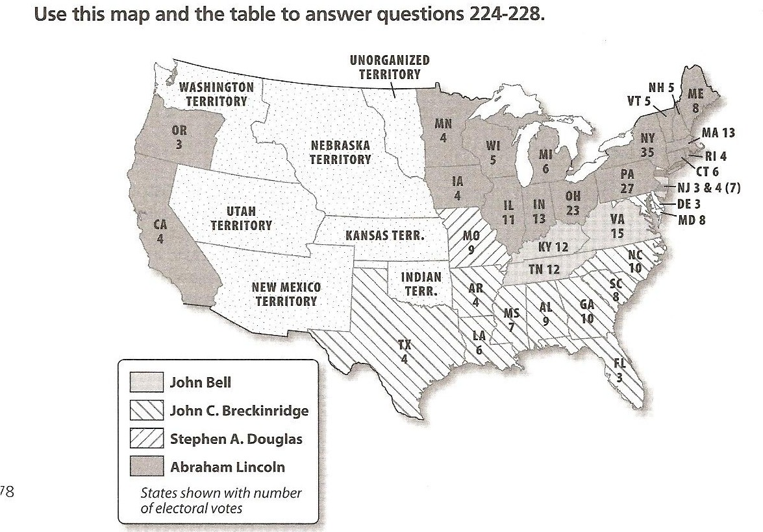

Candidate | Popular Vote Georgia | Popular Vote National | Electoral Vote
Bell | 42,060 | 592,906 | 39
Breckinridge | 52,176 | 848,356 | 72
Douglas | 11,582 | 1,382,713 | 12
Lincoln | 0 | 1,865,593 | 180
TOTAL | 106,717 | 4,689,568 | 303

_____25) Which candidate for president of the United States in 1860 won the electoral vote?
- John Bell b.John Breckinridge Stephen A. Douglas Abraham Lincoln

_____26) Which candidate won the majority of the vote in only two states in his bid for the presidency?
- John bell
- John Breckinridge
- Stephen A. Douglas
- Abraham Lincoln

_____27) Which two candidates split the southern vote?
- Lincoln and Douglas
- Douglas and Breckinridge
- Breckinridge and Bell
- Bell and Lincoln

_____28) Which candidate for president was the choice of people living in Georgia?
- John Bell
- John Breckinridge
- Stephen A. Douglas
- Abraham Lincoln

_____29) Which state had the most electoral votes in 1860?
- California b. Georgia c. New York d. Texas

